Function 2 CDV
City Delivery Variance
Earned Methodology

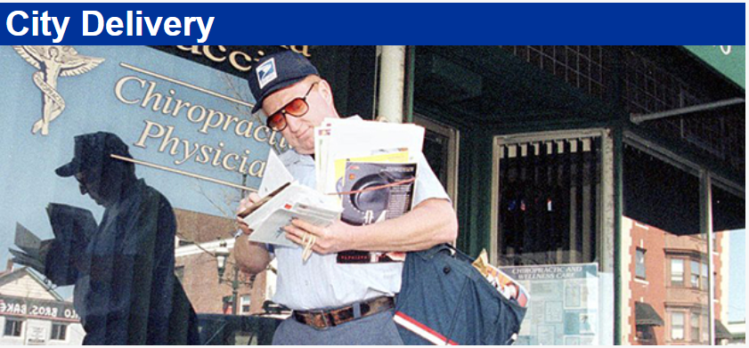

Workhour Efficiency
August 2024
Table of Contents

1 Introduction 3
1.1 Purpose 3
1.2 Stakeholders 3
1.3 Complement Analysis 4
1.4 Workhour Effiency Support 4
2 CDV Earned Workhour Analysis 5
2.1 Earned Office Workhour AnanlsisCustomer Service Modules 5
2.2 Purpose LDC 26 Earned Methodolgy 5
2.3 LDC 22 Earned Methodology 6
2.4 LDC 23 & 27 Earned Methodology 6
3 CDV Earned Workhour Calculations 7
3.1 LDC 21- Earned Office Workhour Calculation- Option 1 7
3.2 LDC 21- Earned Office WorkhourCalculation- Option 2 8
3.3 LDC 26 Earned Office Workhour Calculation 8
3.4 FOT Earned Office Workhour Calculation- Option 1 Office Break 9
3.5 FOT Earned Office Workhour Calculation- Option 2 No Office Break 9
3.6 Earned Street Hours 10
3.7 Earned Other Workhour Calculation 10
4 Workload & Productivity Analysis / Calculations 11
4.1 Workload Analysis 11
4.2 Productivity Analysis 12
4.3 Earned Productivity Calculations 12
4.4 Unit Route and Delivery Analysis 12
4.5 CDPOM Analysis / Earned Calculation 13
5 F2B Performance FY24 YTD …………………………………………………………… 14
6 F2B Operation Codes ……………………………………………………………………… 15
Introduction

Purpose

The City Delivery Variance, (CDV) is the Function 2B model in the suite of Workhour Efficiency Management. CDV is a management model that provides complement, workhour, productivity, workload, and route/delivery analysis. CDV calculates actual versus earned workhour performance against standardized target productivity expectations and trends performance from national results to the unit level. CDV utilizes integrated data from Delivery Operations Information System (DOIS), EFlash and WebCOINS to identify savings opportunity in a relevant and actionable performance management platform. ​

Workhour Analysis
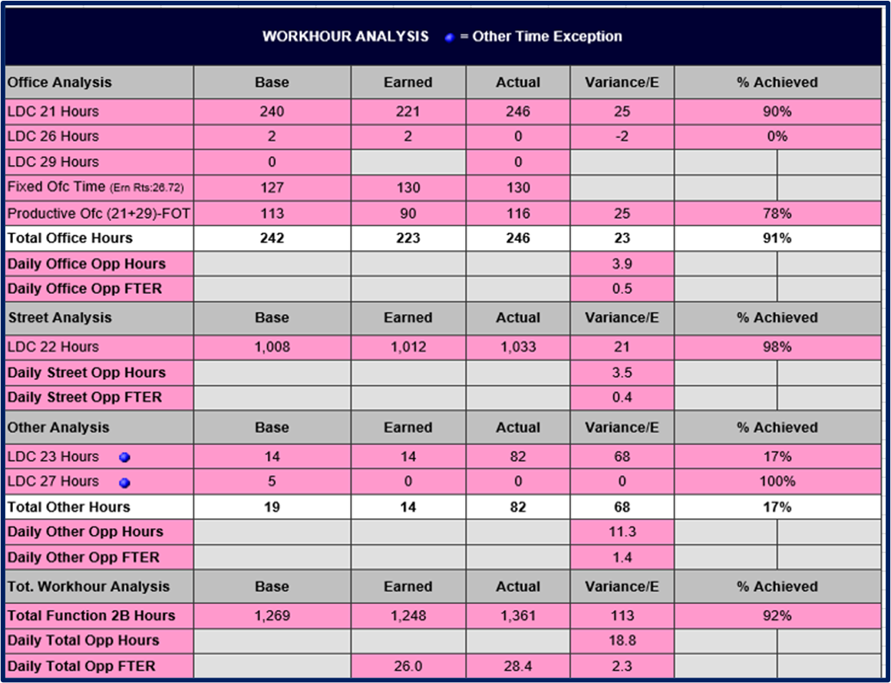

Stakeholders

- Vice President Retail and Delivery Operations
- Vice President Delivery Operations
- Vice President Delivery Operations City Delivery Strategy & Policy
- Vice President Area Retail & Delivery Operations
- Dir Field Operations Support
- District Managers
- District Managers Operation Integration
- Manager Post Office Operations
- Postmasters
- Station Managers

Complement Analysis

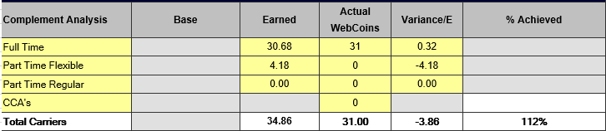

Calculations Full Time Carriers
Total earned complement*88%

Calculations Part Time Flexible Carriers
Total earned complement*12%

- Vice President Retail and Delivery Operations
- Vice President Delivery Operations
- Vice President Delivery Operations City Delivery Strategy & Policy
- Vice President Area Retail & Delivery Operations
- Dir Field Operations Support
- District Managers
- District Managers Operation Integration
- Manager Post Office Operations
- Postmasters
- Station Managers

Workhour Efficiency Support

Workhour Efficiency Support WorkhourEfficiencySupport@usps.gov\

CDV Earned Workhour Analysis

2.1 Earned Office Workhour Analysis

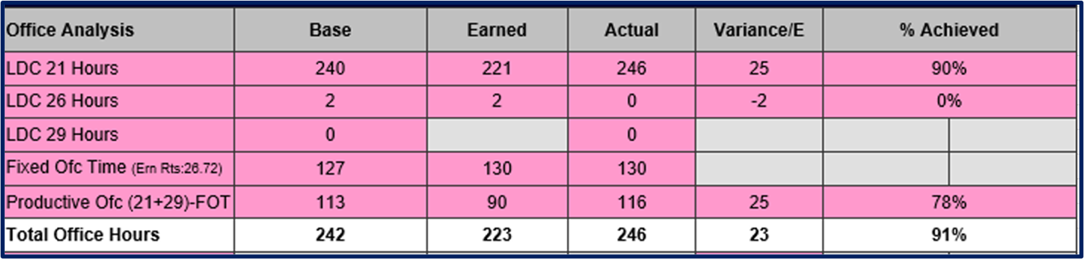

LDC 21 Earned Office Hour Methodology
Option 1
  - Unit receives DPS and is > 90% Then (((Act. Cased Ltrs/18/60)+(Act. Cased Flts/8/60))+((Act cased Ltrs + Cased flts)/70/60))*90%+FOT
Option 2
  - Unit receives DPS and is < 90% Then (((Cased Ltrs + DPS * 10%/18/60)+(Act. Cased Flts/8/60))+((Act cased Ltrs + DPS )* 10% + Cased flts)/70/60))*90%+FOT

Purpose LDC 26 Earned Methodology

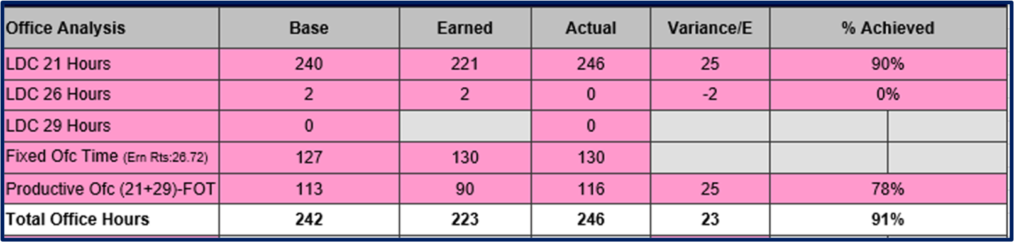

LDC 26 Earned Methodology
  - ((Base City Rts*4)/302)*Del Days

FOT Earned Methodology
Option 1
    - If Office Break = Y then Base FOT* # of Del Days + 0.17 * # of Earned Rtes
Option 2
If Office Break = N Base FOT * # of Del Days * # Earned Rts

LDC 22 Earned Methodology

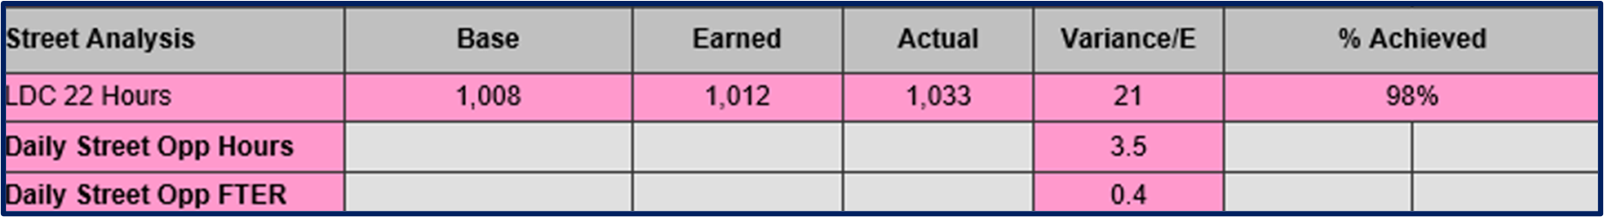

LDC 22 Earned Methodology
  - (Actual PDs / Earned SEI) +/- difference of DOIS Base parcels and PKCC. Adjustment is +1 minute per PKCC over DOIS Base parcels, -1 minute per PKCC under DOIS Base parcels.

Earned LDC 23 & LDC 27 Methodology

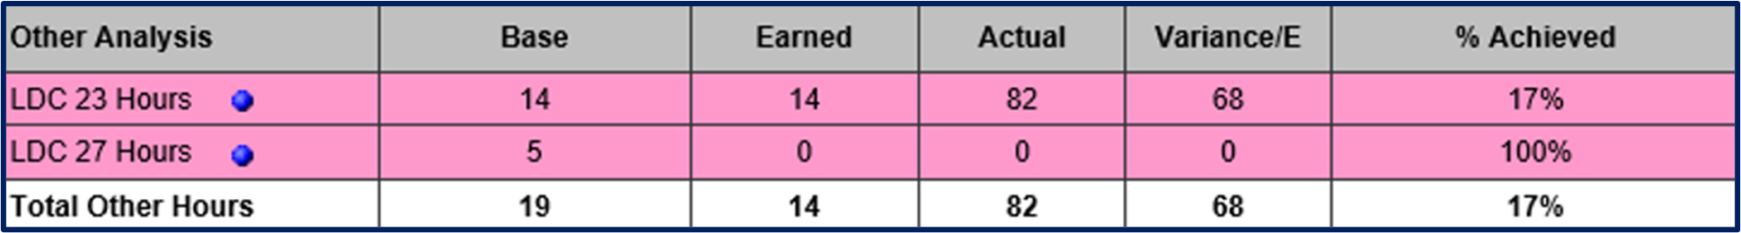

Base LDC 23 & LDC 27
- MOPS Defined Hours / Days

Earned LDC 23 Methodology
- Actual, Capped at Base LDC23 * # of Del Days + (Sunday AAU / 18.18 Parcels Per Hour)
Earned LDC 27 Methodology
Actual, Capped at Base LDC27 * # of Del Days

3 CDV Earned Workhour Calculations

3.1 LDC 21 - Earned Office Workhour Calculation Example – Option 1 DPS >/= 90%

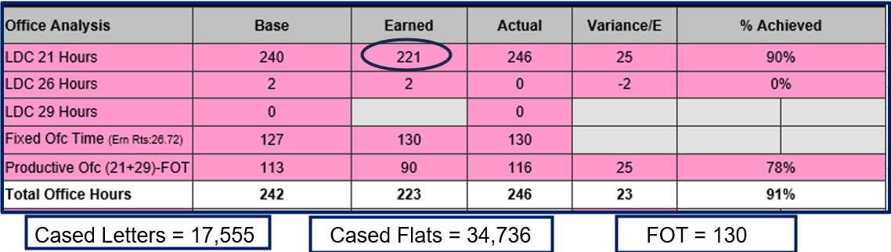

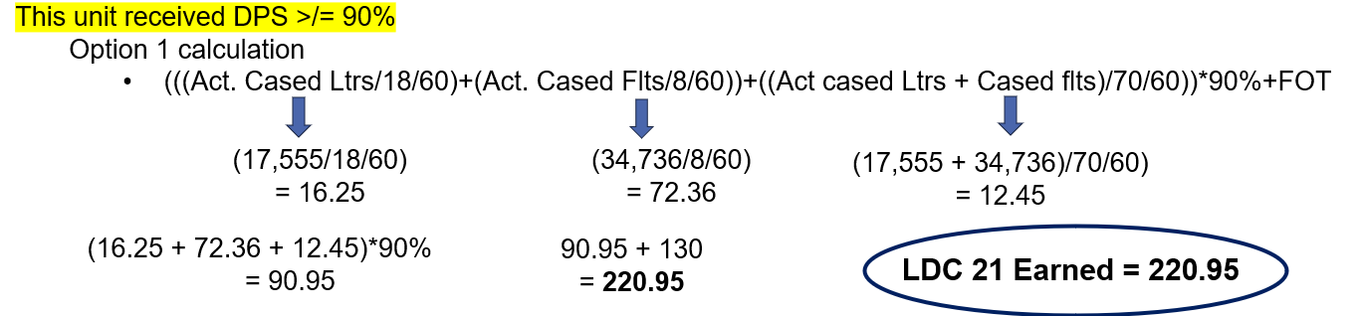

3.2 LDC 21 - Earned Office Workhour Calculation Example – Option 2 DPS < 90%

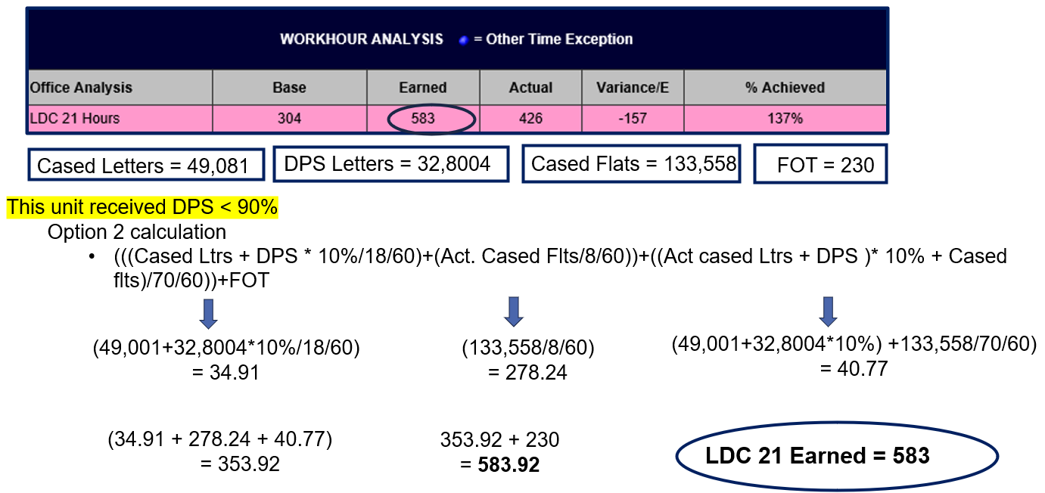

3.3 LDC 26 Earned Office Workhour Calculation

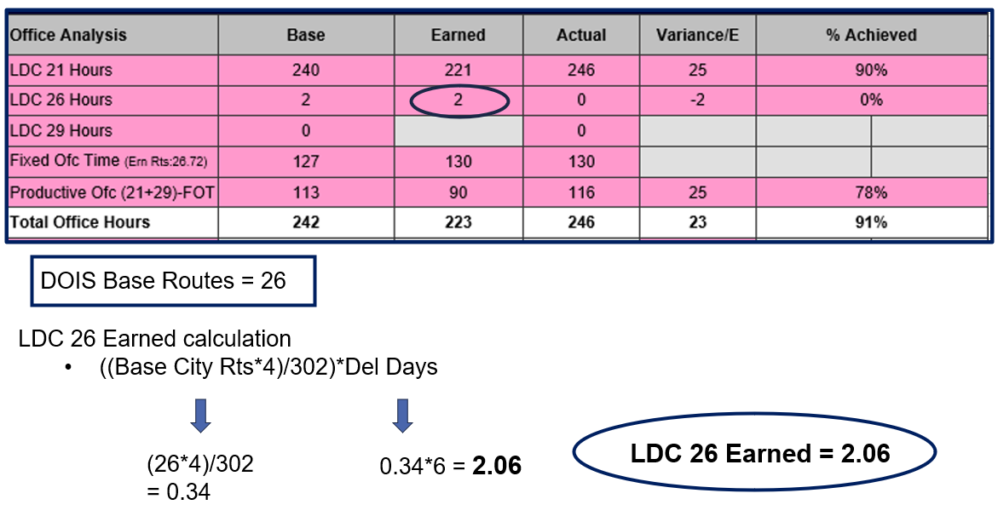

3.4 FOT Earned Office Workhour Calculation – Option 1 Office Break

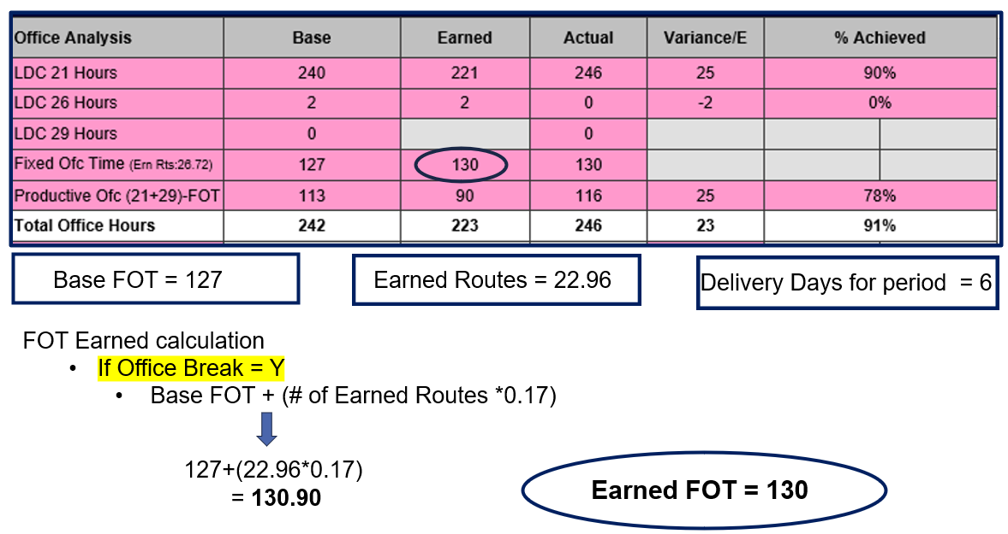

3.5 FOT Earned Office Workhour Calculation – Option 2 No Office Break

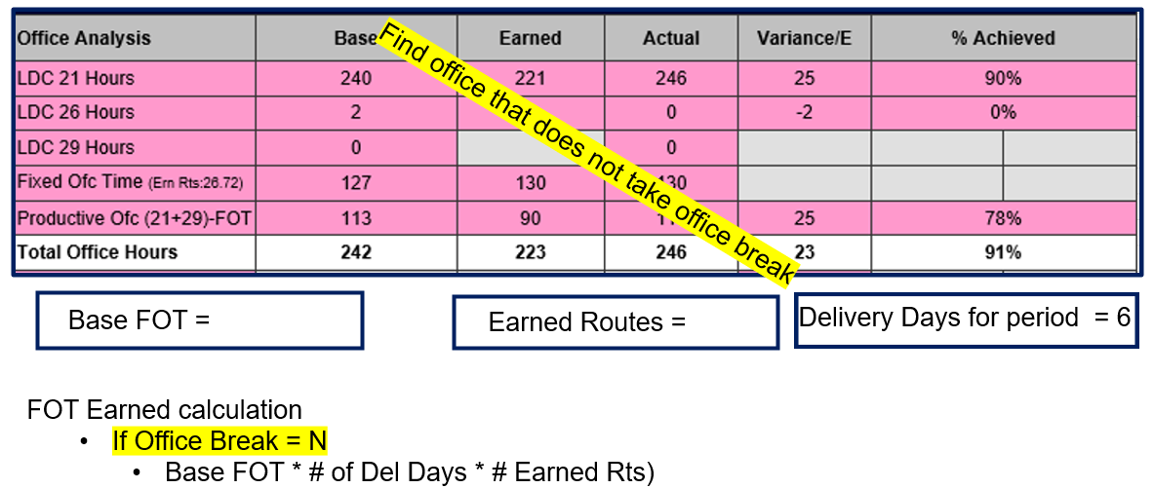

3.6 Earned Street Workhour

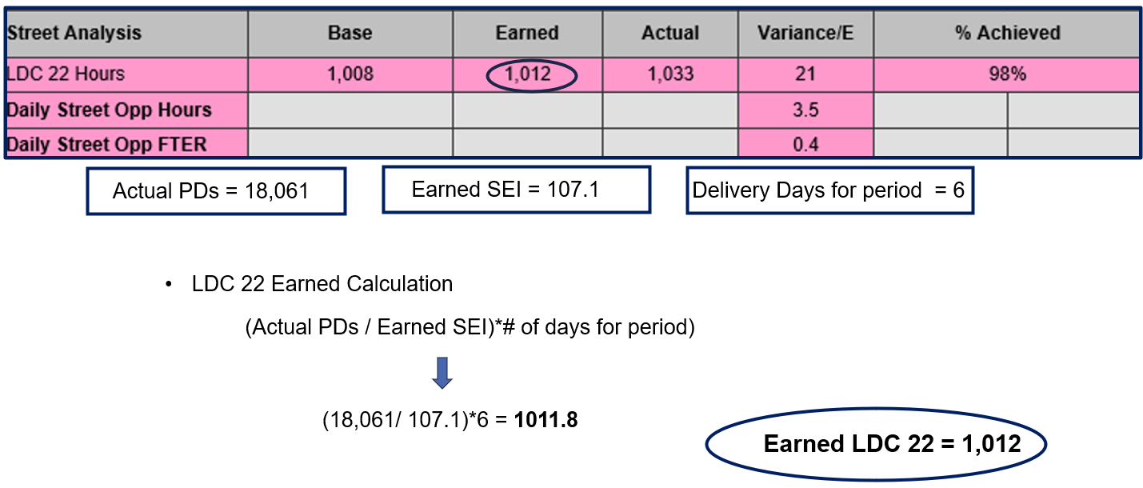

3.7 Earned Other Workhour Calculations

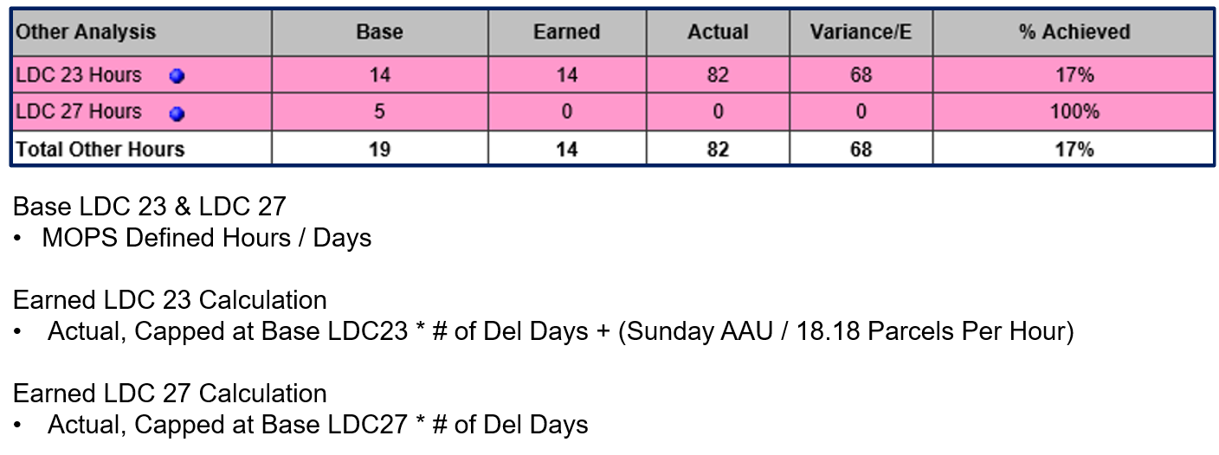

Enterprise Data Hub

4 Workload & Productivity Analysis / Calculations

4.1 Workload Analysis

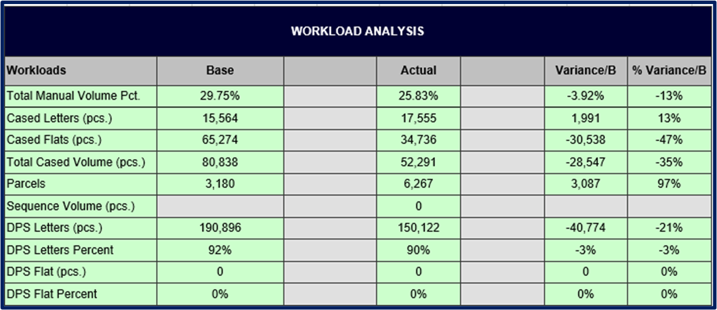

- Actual Workload weekly data from eFlash

4.2 Productivity Analysis

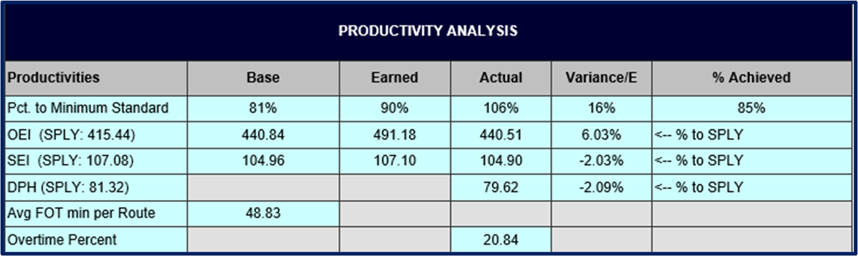

Earned Productivity Methodology

- % to Minimum Standard = 90%
- OEI = Earned PD's/Earned Total Office Hours
- SEI = (Base Deliveries/Base LDC22 (Base SEI)) / 98%

4.3 Earned Productivity Calculations

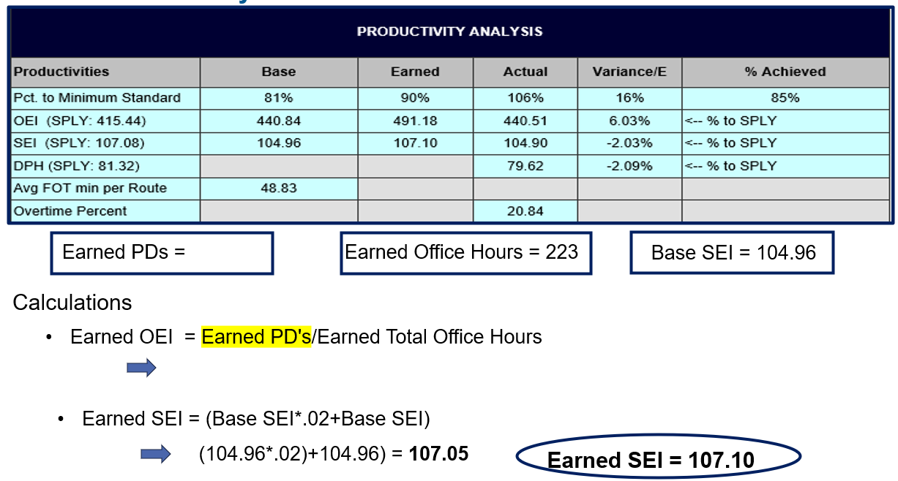

4.4 Unit Route and Delivery Analysis

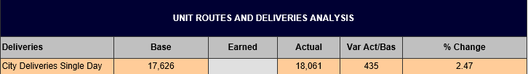

- Total single day deliveries

4.5 CDPOM Analysis / Earned Calculation

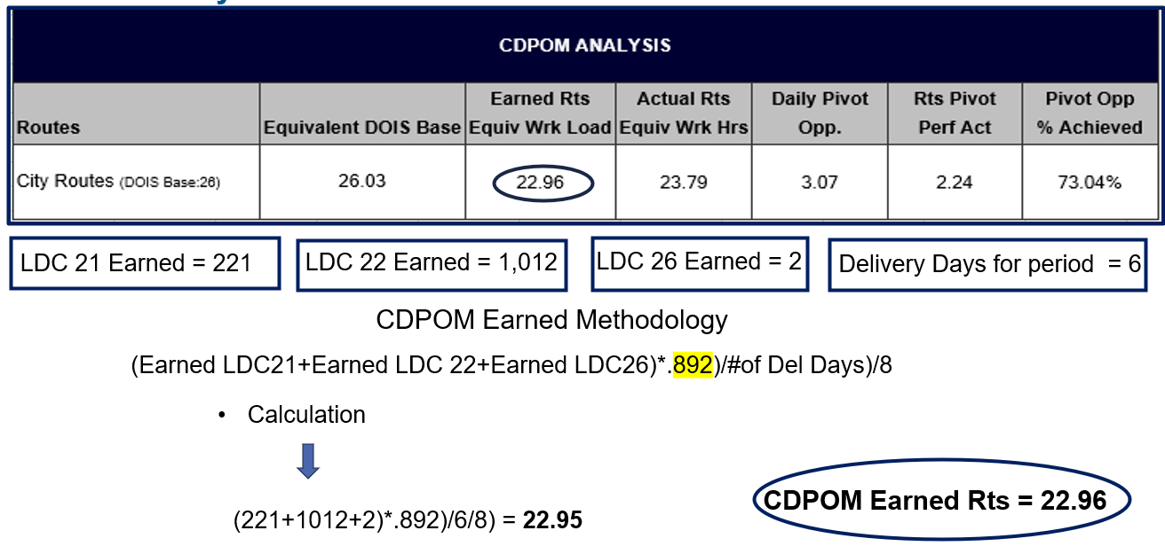

FY24 YTD F2B Performance by LDC

FY24 F2B Performance as of WK43B

F2B Operational IDs

